Embracing Continuous Delivery with Release Management for Visual Studio 2017

Lab version: 15.0.26020.0

Last updated: 2/27/2017

1. **TABLE OF CONTENTS**

Overview 1

Prerequisites 2

About the Fabrikam Fiber Scenario 2

Exercise 1: Continuous Release Management 2

Task 1: Configuring a continuous build 2

Task 2: Creating a continuous release 8

Exercise 2: Gated Releases 18

Task 1: Adding a QA environment 18

Exercise 3: Releasing To Azure 22

Task 1: Creating an Azure Web site and database 22

Task 2: Configuring the build to produce a Web Deploy package 31

Task 3: Creating a release environment for Azure 32

Task 4: Checking in a change to kick off the release workflow 40

Task 5: Deploying to Azure from Visual Studio 41

Task 6: Working with deployment slots 47

# Overview

* 1. In this lab, you will learn about the release management features available in Visual Studio 2017 and its suite of release and deployment tools that automate the deployment of applications across the desktop, server, and the cloud. The release management features of Visual Studio 2017 help development and operations teams integrate with Team Foundation Server to configure and automate complex deployments of their automated builds to target environments more easily. Development teams can also model their release processes and track approvals, sign-offs, and visualize their release status.

## Prerequisites

* 1. In order to complete this lab you will need the Visual Studio 2017 virtual machine provided by Microsoft. For more information on acquiring and using this virtual machine, please see [this blog post](http://aka.ms/almvm).

## About the Fabrikam Fiber Scenario

* 1. This set of hands-on-labs uses a fictional company, Fabrikam Fiber, as a backdrop to the scenarios you are learning about. Fabrikam Fiber provides cable television and related services to the United States. They are growing rapidly and have embraced Windows Azure to scale their customer-facing web site directly to end-users to allow them to self-service tickets and track technicians. They also use an on-premises ASP.NET MVC application for their customer service representatives to administer customer orders.

In this set of hands-on labs, you will take part in a number of scenarios that involve the development and testing team at Fabrikam Fiber. The team, which consists of 8-10 people has decided to use Visual Studio application lifecycle management tools to manage their source code, run their builds, test their web sites, and plan and track the project.

* 1. Estimated time to complete this lab: **60 minutes**.

# Exercise 1: Continuous Release Management

In this exercise, you will use the release management features of Team Foundation Server to produce an automated deployment solution. This exercise will take an existing enterprise application and automate its deployment to the development team’s testing environment after each source check-in.

## Task 1: Configuring a continuous build

1. Log in as **Brian Keller** (VSALM\Brian). All user passwords are **P2ssw0rd**.
2. Open **Internet Explorer**.
3. Navigate to the **TFS FF Portal** using the bookmark at the top of the browser.

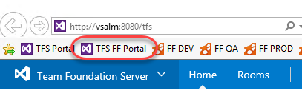

1. Click the **Code** tab.

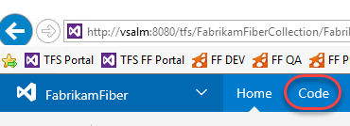

1. You can easily edit files on the server and check them in from the browser, which is great for scenarios where you only need to make minor tweaks. You’ll come back to this tab in future steps, so leave it open as you move forward.
2. Right-click the **Build & Release | Builds** tab and select **Open in new tab** to view builds. You’re going to move back and forth between parts of TFS, so keeping these separate tabs open will make things easier as you go along. After the tab opens, switch to it.

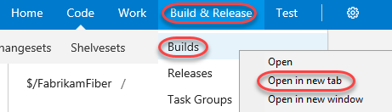

1. Click **New definition** to create a new build definition.

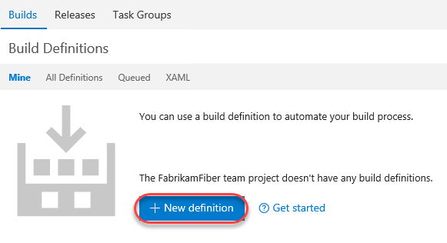

1. Select the **Visual Studio** template and click **Next**.

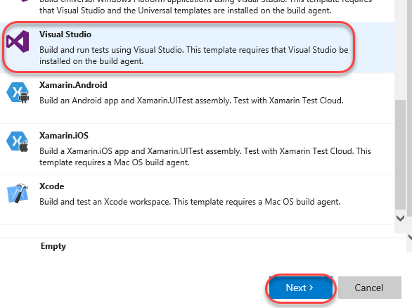

1. The default settings are fine here, so just check the box to enable **continuous integration** and click **Create**.

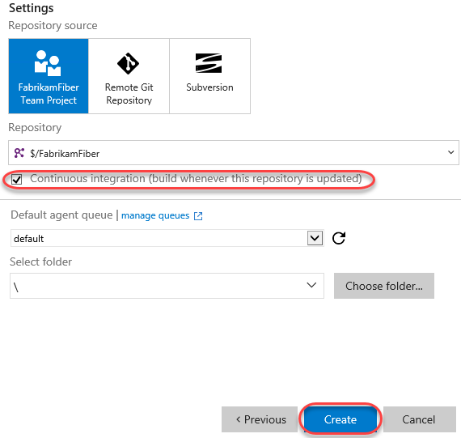

1. Select the **Repository** tab and update the **Mappings** so that both use the **“$/FabrikamFiber/Dev”** branch.

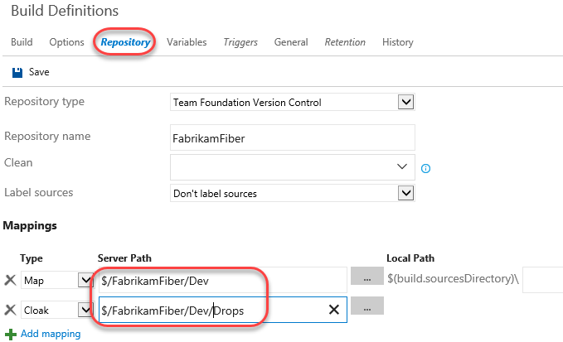

1. Return to the **Build** tab and select the **Visual Studio Build** step. Set the **MSBuild Arguments** to the text below. Also change the **Visual Studio Version** to **Visual Studio 2017**.
2. /p:OutDir=$(build.stagingDirectory)

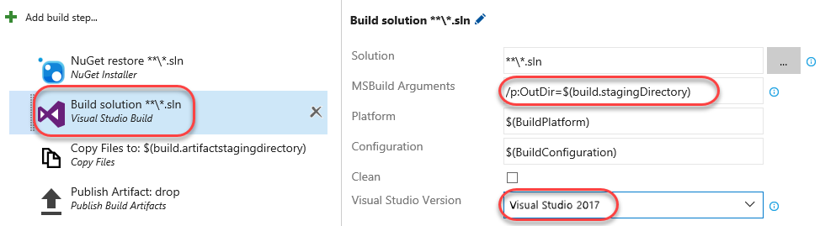

1. Remove the **Visual Studio Test** and **Index Sources & Publish Symbols** steps from the process.

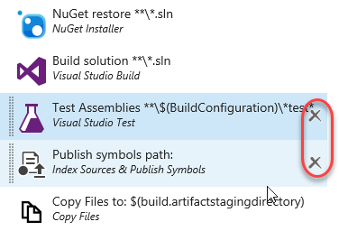

1. Click **Save**.

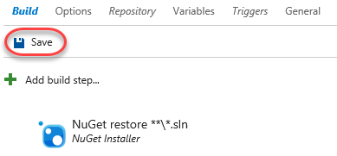

1. Set the **Name** to **“Fabrikam Development CI”** and click **OK**.

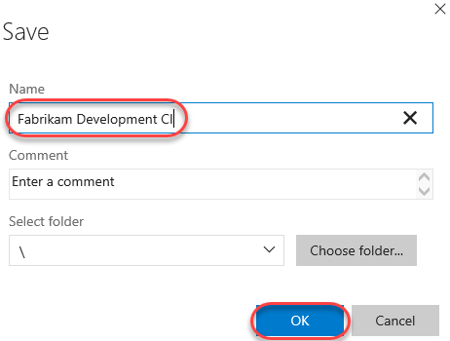

1. Return to the browser tab opened to the **Code** hub.
2. Navigate to the path below to open a shared layout file used to present a consistent look and feel for the site.
   1. $/FabrikamFiber/Dev/FabrikamFiber.CallCenter/FabrikamFiber.Web/Views/Shared/_Layout.cshtml

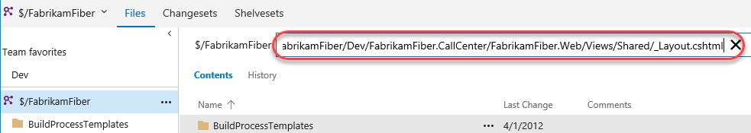

1. Click **Edit** to enable editing directly in the browser.

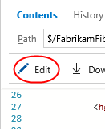

1. Locate the “Support” text within a **H2** tag (around line 29). Change it to “Support v2.0” and click the **Save** icon to check in the change. This check-in will invoke a build now that continuous integration builds have been enabled.

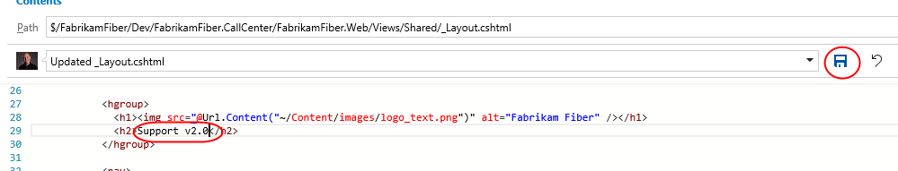

1. Switch back to the browser tab with the builds. Select the **Builds** tab.

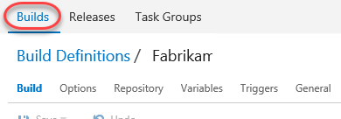

1. There should now be a build in progress. Click it to review the progress.

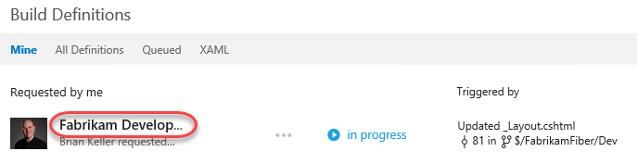

1. You don’t need to wait for the build to complete to move on to the next step.

## Task 2: Creating a continuous release

1. Now that there is an automatic build that occurs when changes are checked in, it’s time to set up a continuous release so that this new build can make its way out to stakeholders. Right-click the **Release** tab and select **Open in new tab**. You should now have three tabs open: Code, Build, and Release. Switch to the Release tab.

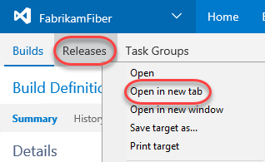

1. To create your first release, click **New definition**.

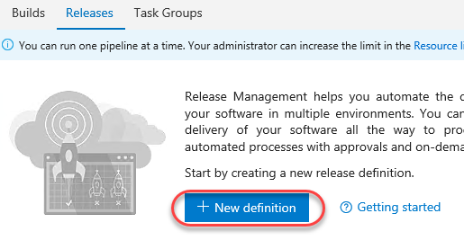

1. Select the **Empty** definition and click **Next**. You may need to scroll down to find it at the bottom.

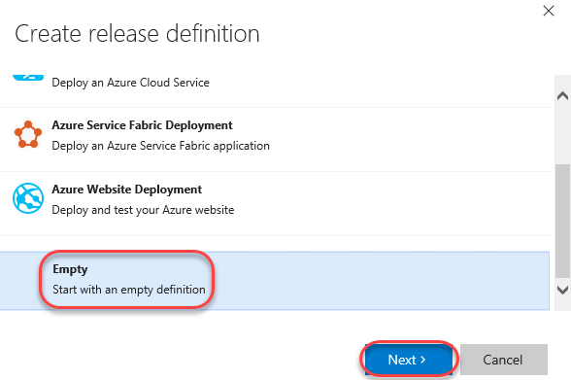

1. Check **Continuous deployment** and click **Create**. This indicates that the release should execute as soon as the build completes. Note that a default build definition is selected, which we could change if needed. It happens to be the one we want to work with here.

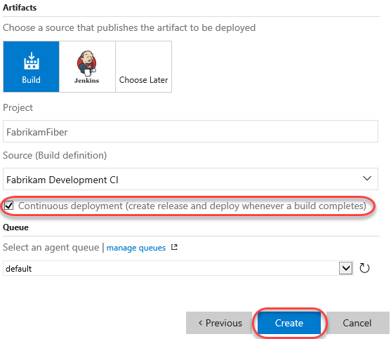

1. Click the **Edit** button and change the release name to “Fabrikam Release” as the release name. Press **Enter**.

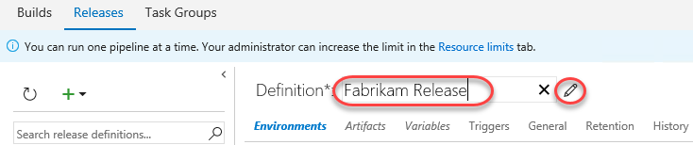

1. By default, there is one environment, which you will rename “Dev”. This will represent the “Dev” environment used by the dev team during development.

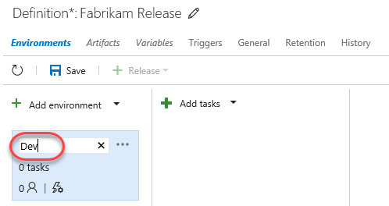

1. The **ellipses** button in the top right corner of the environment card provides quick access to key configuration functionality. You can assign approvers, select an agent queue, and configure variables for the environment. You can also clone the environment, or even save it as a template to easily create other environments from in the future. In this case, the first thing you will do is to indicate the conditions under which it will be deployed to. Click the **ellipses** button and select **Deployment conditions**.

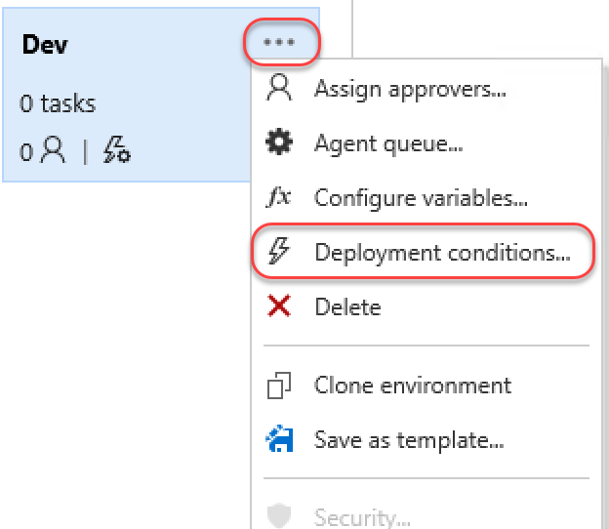

1. Under **Deployment conditions**, note that **After release creation** is already selected because this definition was configured as continuous. Press **Esc** to close the dialog.

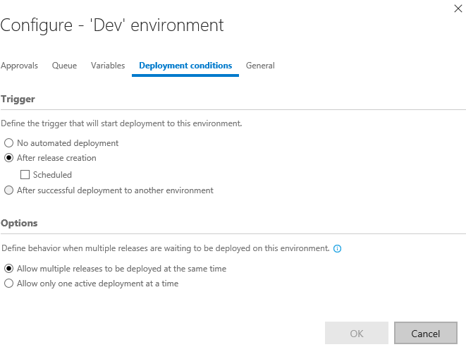

1. Now that the basic settings of the environment have been defined, it’s time to configure exactly how a release is deployed. This is done through a series of **Tasks** that involve any process you need to get the job done. The “Dev” environment is pretty straightforward since it just involves copying files from the build directory to a directory configured to be used by IIS (which happens to be on the same machine in this lab scenario). Click **Add tasks** to select which agent or server tasks you want as part of the workflow. Click **Add an agent phase**.

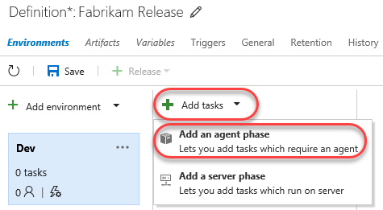

1. Under the **Utility** tab, click **Add** from **Copy Files** to add one of those tasks to the workflow. Note that you could add a variety of tasks to the process, so the dialog doesn’t close after you hit **Add**. Instead, just click it once and then click **Close** to return to the main view.

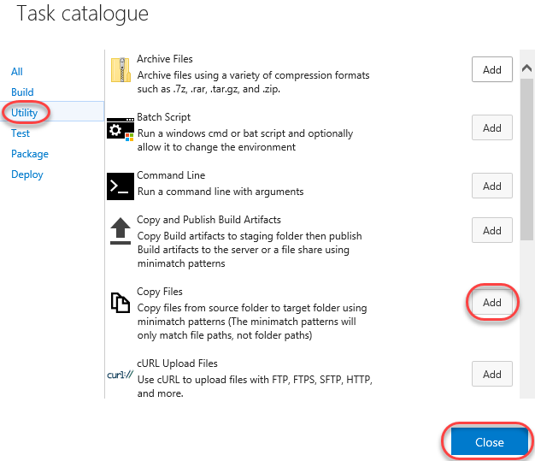

1. There are three key settings for the **Copy Files** task. First, set **Source Folder** to the path below.

$(System.DefaultWorkingDirectory)/Fabrikam Development CI/drop/_PublishedWebSites/FabrikamFiber.Web

1. Next, set **Target Folder** to the path below.
   1. c:\FabrikamRM\WebSite\DEV
2. Finally, expand **Advanced** and check **Overwrite** to indicate that it’s okay to overwrite existing files at the destination.

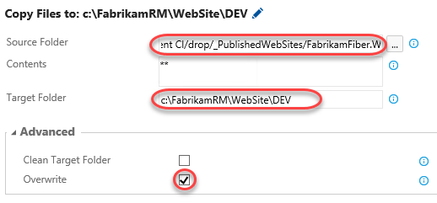

1. Now that this process has been configured, click **Save**.

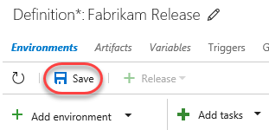

1. Once saved, this release definition will appear in the **Release Definitions** list and offer you easy access to configuration functionality, which includes the ability to clone the definition, as well as to export it for import elsewhere.

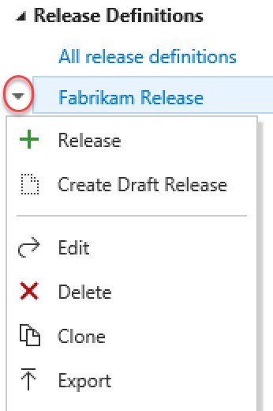

1. Open a new browser tab and navigate to the Fabrikam Fiber Dev site. Note that the “Support” text is still just “Support” because the most recent changes were checked in and built, but not deployed.

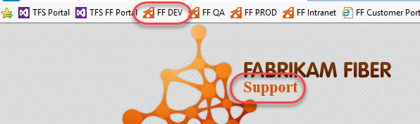

1. Switch to the browser tab open to the builds page (probably the second one).
2. Click **Queue new build**. Note that you could make another change to the source and check it in, but this process cuts to the chase.



1. Accept the defaults and click **OK**.

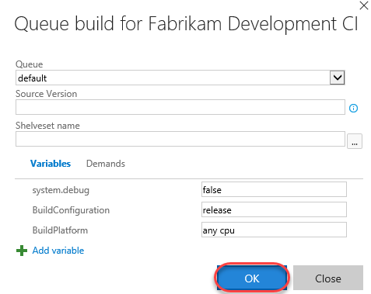

1. Switch to browser tab open to the releases.
2. Select the **Releases** tab to view release history.

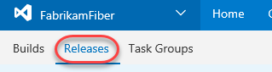

1. If there are no releases in the view, refresh the browser every few seconds (or press the **Refresh** button in the UI). The build should complete pretty quickly and kick off the new release. When it appears, note that there is a single grey bar under **Environments**. This represents the **Dev** environment, which hasn’t begun yet. If the bar is blue, then that means the deployment is in progress. Green means it succeeded and red means it failed. Double-click the release to view the details.

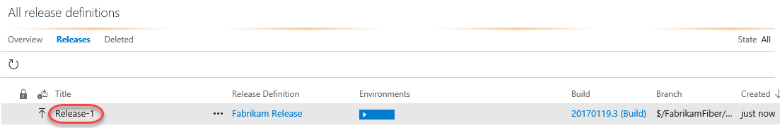

1. There are many options for reviewing the release. Most of these are already familiar since you just went through the process of setting them up. But if you consider a scenario where there are many different releases occurring at the same time, it’s very useful to have easy access to all the settings and details used to define a release. Click the **Logs** tab to watch the process unfold.

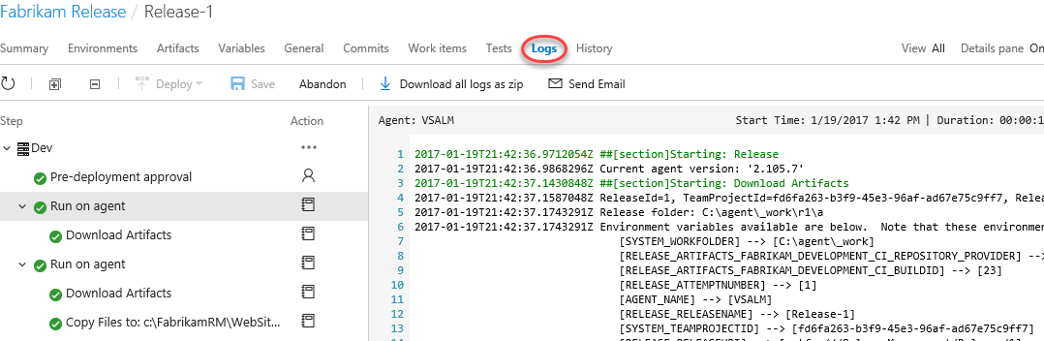

1. Return to the **Summary** tab and refresh the view using the inline **Refresh** button until the deployment succeeds.

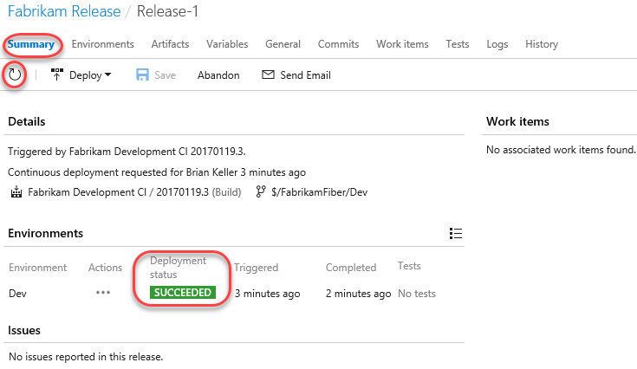

1. Return to the Fabrikam Fiber Dev browser tab and refresh it to confirm the changes have been deployed.

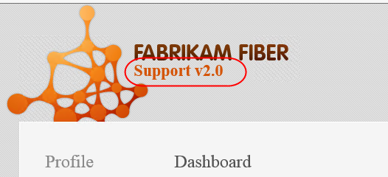

# Exercise 2: Gated Releases

* 1. While automated releases are great, sometimes you want to gate their progress by requiring user approval. In this exercise, you will add a second environment to the release process for QA and user acceptance testing. In this scenario, you will allow the release to reach the QA site, but only if it successfully deploys to Dev. Once it’s available on QA, it won’t be considered “success” until approved manually. Note that it’s just as easy to also (or alternatively) have this human approval gate prior to the deployment.

## Task 1: Adding a QA environment

1. Return to the tab with all the releases (probably the third).
2. Click the release name to return to its overview.

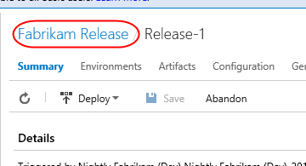

1. Click **Edit** to enter edit mode.

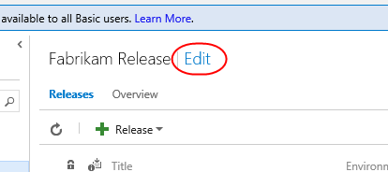

1. Click the ellipses in the **Dev** environment and select **Clone environment**. Your **QA** environment is the same as **Dev**, except that it’s copied to a different output folder. Using this clone technique saves a lot of configuration time.

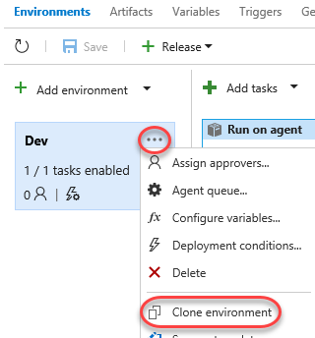

1. In the **Add new environment** dialog, select the option to specify **Specific users** for pre-deployment approval. Add **Brian Keller** as the user. Also ensure the **Deploy automatically** box is checked before clicking **Create**. Note that you can also configure post-deployment approvers and other common behaviors later on.

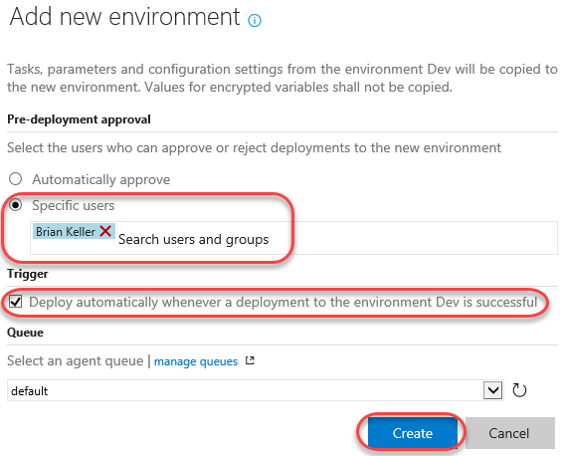

1. Change the name of the new environment to “QA” and press **Enter**.

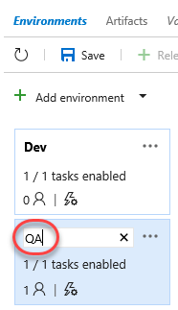

1. In the **Copy Files** task, change the final destination folder from “DEV” to “UAT” (short for “User Acceptance Testing”).

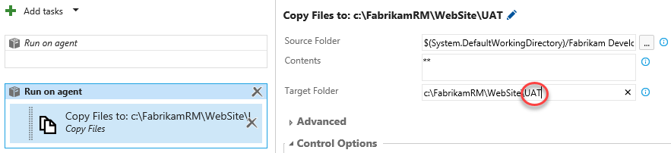

1. **Save** the release.

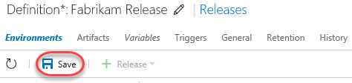

1. Open a new browser tab and navigate to the Fabrikam Fiber QA site. Note that it still has the original support text.

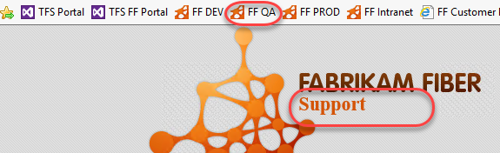

1. Return to the browser tab open to the code view in TFS (probably the first one) and repeat the editing process to change the “Support v2.0” text to “Support v3.0”. Save and check in the change as before. This will kick off the build, which will hand off to the release to Dev, which will hand off to QA.
2. Return to the releases tab and click the link to view release history.

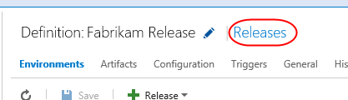

1. Note now that there are two release bars indicating status. Depending on how quickly you get here, these colors may vary by how far the release workflow has progressed. Refresh the data until you see the “awaiting approval” icon shown below (next to the blue bar). Click it when shown.

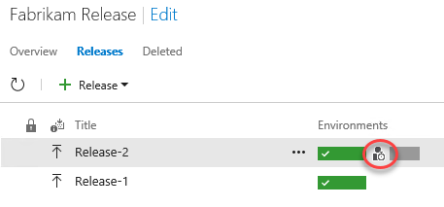

1. Enter an optional message and click **Approve**.

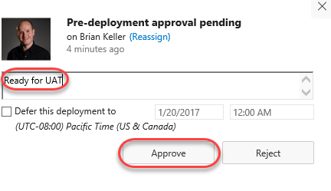

1. Refresh the results until both bars are green, which will indicate that both environment releases succeeded.

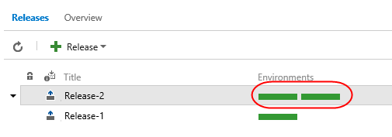

1. Return to the FF QA site (probably the last tab) and confirm the “v3.0” made it through.

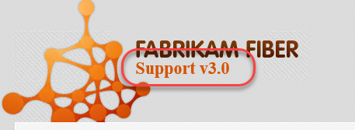

# Exercise 3: Releasing To Azure

The release management tools are incredibly flexible. Not only can you automate virtually anything, you can even leverage some of the higher-lever tasks to easily perform complex processes, such as deploying to an Azure web site.

## Task 1: Creating an Azure Web site and database

1. Create an Azure account at <http://azure.com> if you don’t already have one.
2. In a new browser tab, navigate to <https://portal.azure.com>.
3. Select **+New | Databases | SQL Database** to create a new database.

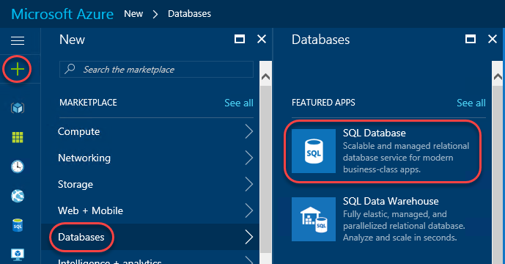

1. Enter “fabrikam” as the **Database name**. Select a subscription (it doesn’t matter which one, but use the same one for all steps in this lab). Select **Create new** for **Resource group** and enter “fabrikam” as the name. Make sure **Select source** is set to **Blank database** and click **Configure required settings**.

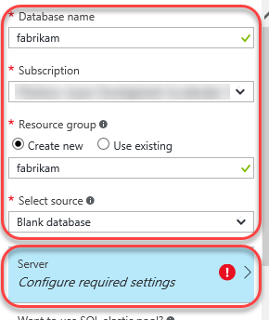

1. Click **Create a new server**.
2. Enter a unique name for **Server name**, such as by including your name. Enter a admin username and password you can remember. Note that “P2ssw0rd” meets the password requirements. Click **Select** to select these options.

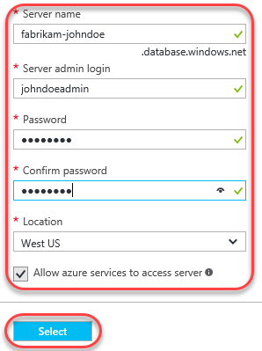

1. Click **Create** on the first blade to create the database and server. It’ll take some time to complete, but you can move on to the next step while it works in the background.
2. Select **+New | Web + Mobile | Web App** to create a new Azure web site.

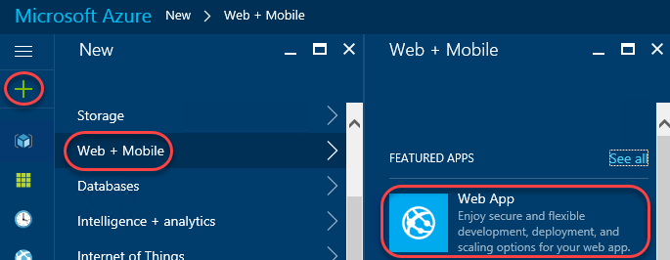

1. For **App name**, enter a unique name, such as by using your name as part. Select the same **Subscription** and **Resource group** as before. If required to create an **App Service plan**, accept the defaults. Click **Create** to create.

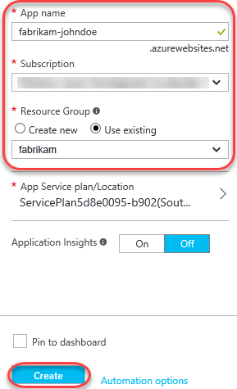

1. Click the **Resource groups** tab from the left menu. Locate and click the **fabrikam** group created earlier.

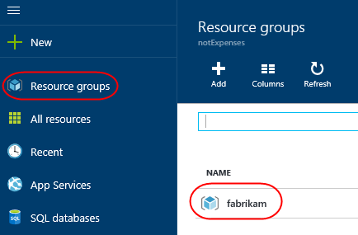

1. Click the SQL Server (not the database) and click **Show firewall settings** in the new blade. There are two SQL icons, and the server is the one with the gear. The database is the one without.

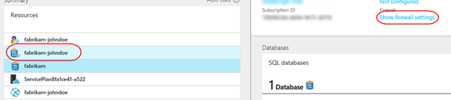

1. You need to allow your current IP address to access the database, so click **Add client IP** (which will default to your current IP) and then click **Save**. No other external IPs will be allowed to connect to your database unless you explicitly let them. Close this blade.

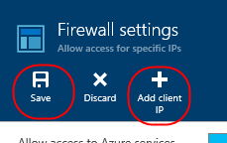

1. From the **Resources** group, click your SQL database (not the server). In the new blade, click **Show database connection strings**.

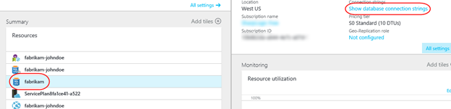

1. This will provide you with a list of connection strings based on platform. Copy the **ADO.NET** string to your clipboard so you can configure your new web site to use it. Close this blade.

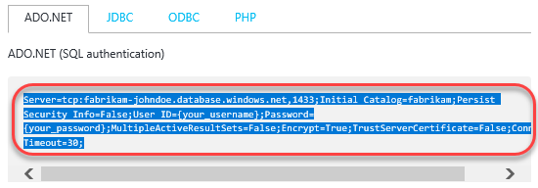

1. Open a new instance of **Notepad** and paste the connection string into it. This will make it easier to edit and retrieve later on in case anything happens to the clipboard copy.
2. On the **fabrikam** database blade, click **Delete** and then confirm the deletion. You’ll publish an existing database using **SQL Server Management Studio** later on.

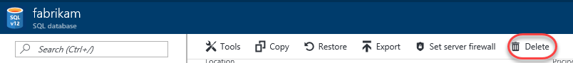

1. In the **Resources** panel, click the web app created earlier. It’s the one with the globe icon by itself. In the rightmost blade that opens, click **Application settings**. Note that if the web app isn’t available yet, you can refresh the view by clicking the **fabrikam** link under **Resource group** in the database blade.

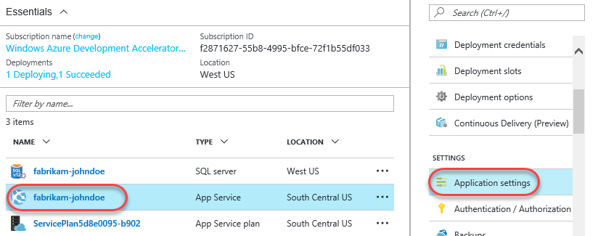

1. On this blade you can configure settings for your app, such as connection strings. Locate the **Connection strings** section and add a new entry with the key “FabrikamFiber-Express” and the value pasted from the clipboard. You’ll need to locate the “{your_password_here}” section and replace it (including braces) with the actual SQL password entered earlier. Press **Enter** to complete.

Server=tcp: fabrikam-johndoe.database.windows.net,1433;Database=fabrikam;User ID=johndoeadmin@fabrikam-johndoe;Password={your_password_here};Encrypt=True;TrustServerCertificate=False;Connection Timeout=30;

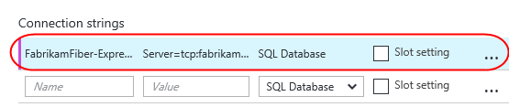

1. Click **Save** from the toolbar to commit.

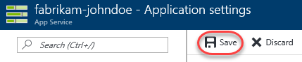

1. By now the SQL database should be available for use. From the **Start Menu**, enter “SQL Server Management Studio” and launch that app.

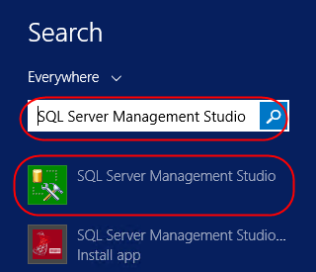

1. By default, the settings are in place for the local SQL server that hosts the database you want to set up in the cloud. Click **Connect** to connect.

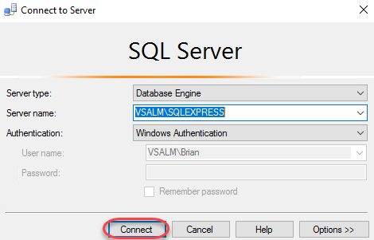

1. Right-click the **FabrikamFiber-Express** database and select **Tasks | Deploy Database to Microsoft Azure SQL Database**.

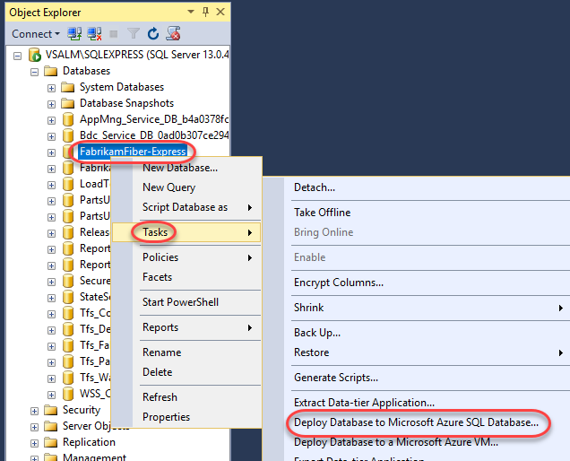

1. On the **Introduction** page of the wizard, click **Next**.
2. Click **Connect** to set up the SQL Azure database connection.

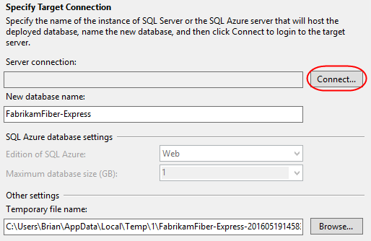

1. In the **Connect to Server** dialog, enter the connection details for your SQL Azure database. For example, if your database name was “fabrikam-johndoe”, then the **Server name** is “fabrikam-johndoe.database.windows.net”. Click **Connect** when done. Note that if you plan to copy/paste any of this into the dialog you’ll want to first paste the current clipboard contents (the SQL script) into Notepad for temporary safekeeping.

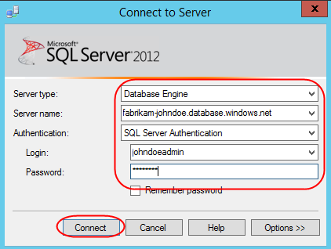

1. Set **New database name** to **“fabrikam”** and click **Next**.

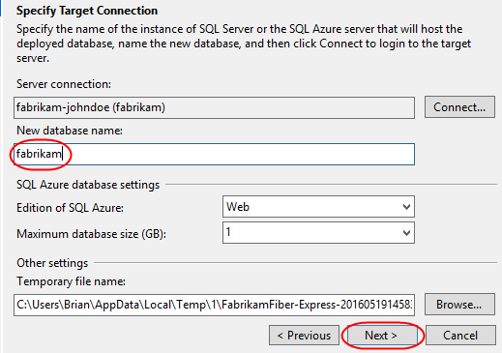

1. Click **Finish** on the final page of the wizard to deploy the database.

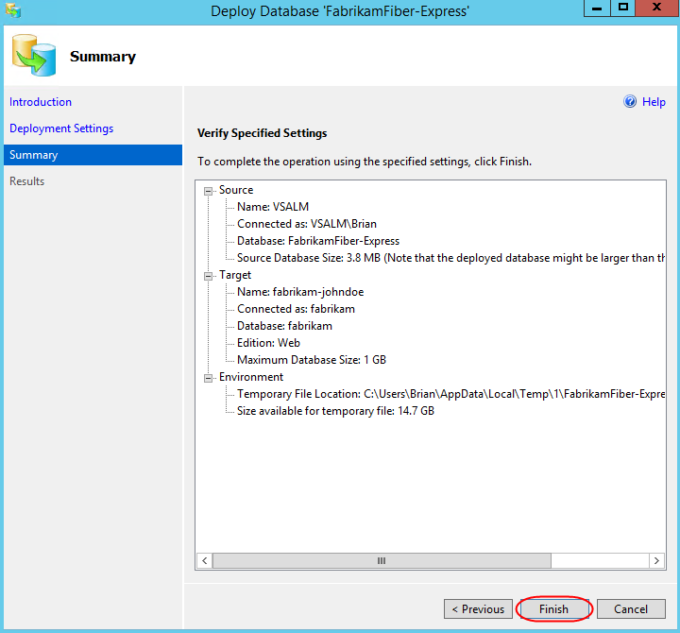

## Task 2: Configuring the build to produce a Web Deploy package

1. Return to the browser tabs open to the builds section of the portal.
2. Click **Edit** to edit the build definition.



1. Select the **Visual Studio Build** step and add the following arguments after the existing arguments. Be sure to include a space before adding the new arguments.
   1. /p:DeployOnBuild=true /p:WebPublishMethod=Package /p:PackageAsSingleFile=true /p:SkipInvalidConfigurations=true

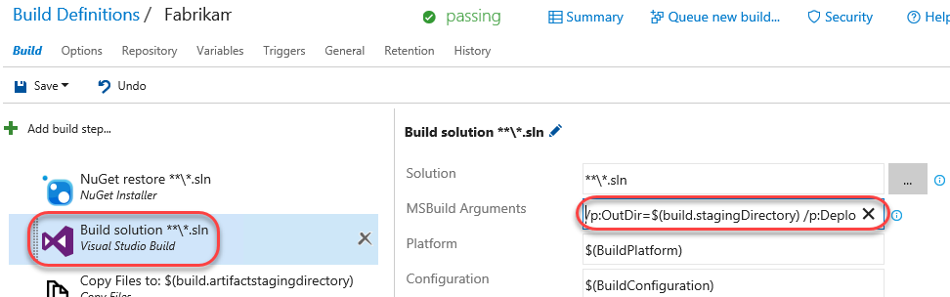

1. Click **Save** to save the build definition. It will now produce the web deploy zip needed for publication to Azure.

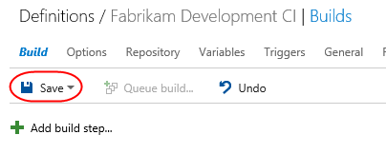

## Task 3: Creating a release environment for Azure

1. Return to the **Releases** tab.
2. Everything has been set up for releasing to Azure, so you just need to add an environment for it. Click the **Edit** link to enter edit mode.

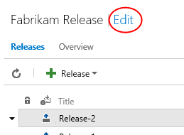

1. Select **Add environment | Create new environment**.

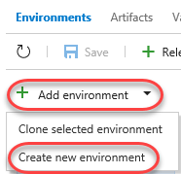

1. Select the **Azure Website Deployment** template and click **Next**.

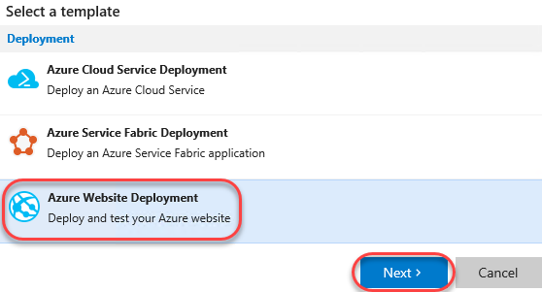

1. Select **Brian Keller** as the pre-deployment approver again and click **Create**.



1. Set the name of the new environment to **Prod-Azure** and press **Enter**.

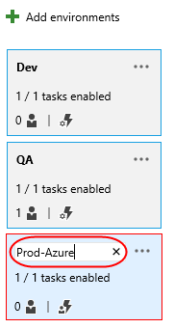

1. Click the **Ellipses** button for **Prod-Azure** and select **Assign approvers**.

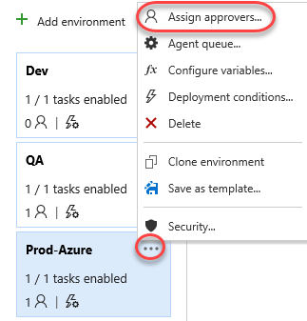

1. Add **Brian Keller** as the post-deployment approver and click **OK**.

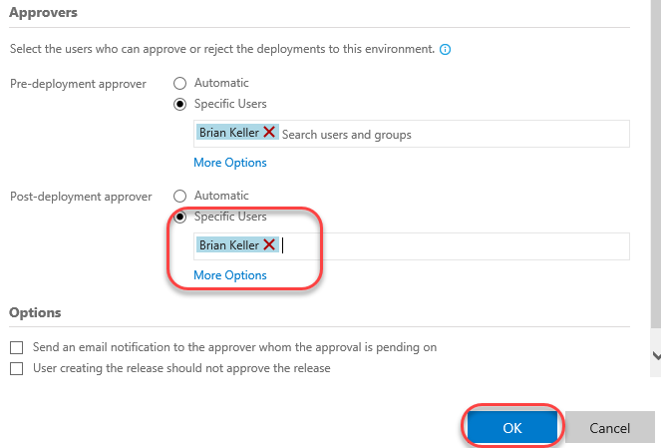

1. There are many tasks available for managing releases to Azure. Select **Add tasks | Add an agent phase** to review them.

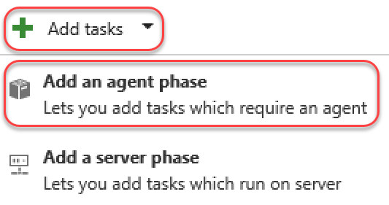

1. The **Deploy** tab provides many key deployment features, such as the ability to run **PowerShell** scripts in an Azure environment, deploy **Azure SQL** databases, and even deploy **AzureRM** and **classic** apps. Press **Esc** to dismiss the dialog.

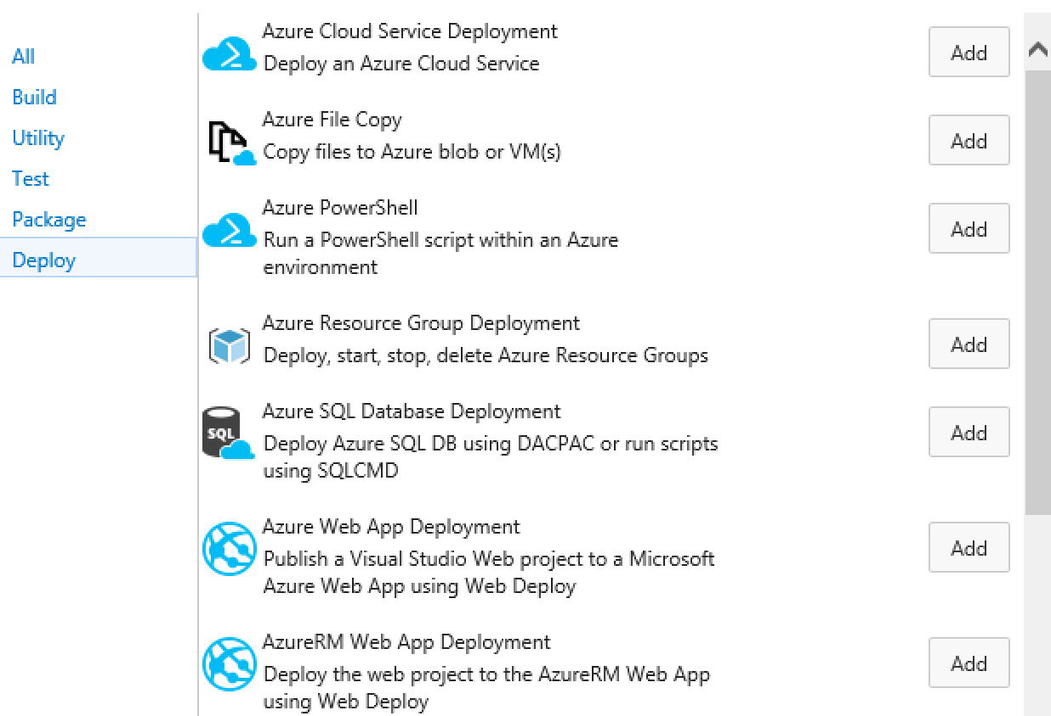

1. However, sometimes there are tasks that cannot be automated and require manual intervention. In that case, you can still automate the processes around it and provide an indicator for TFS to wait for the manual process to complete before continuing. Select **Add tasks | Add a server phase**.

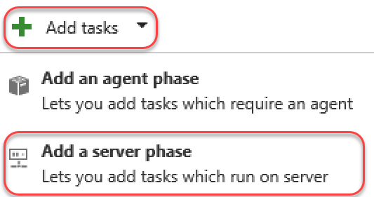

1. We don’t have a need for this right now, so press **Esc** to dismiss the dialog.

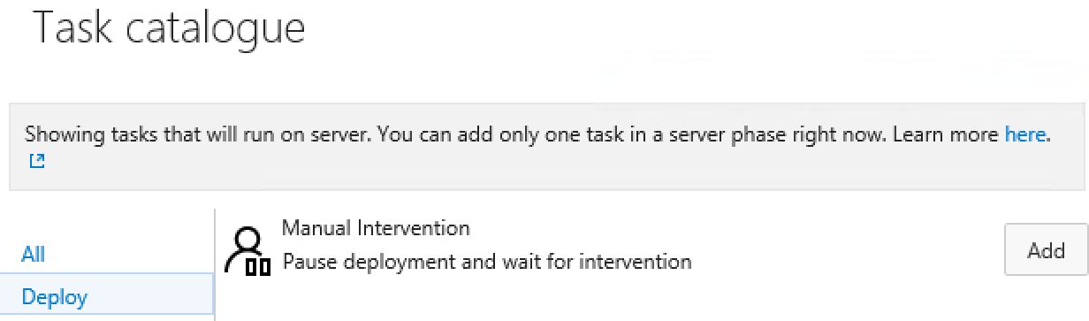

1. Let’s return our focus to the straightforward Azure deployment at hand. Remove the **Visual Studio Test** task from the workflow to keep things simple.

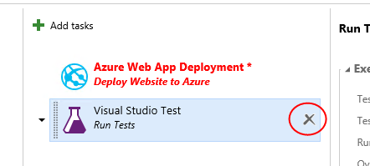

1. It’s now time to configure the connection to Azure. Click the **Manage** link next to the **Azure Subscription** field. This will bring you to the Azure connection configuration page.

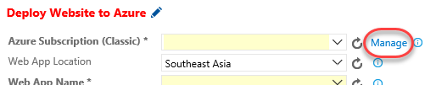

1. Click **New Service Endpoint | Azure Classic**.

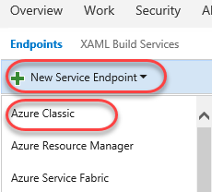

1. Select **Certificate Based** and click the **publish settings file** option at the bottom. This will open a link to download a publish settings file that contains the details needed to complete this form.

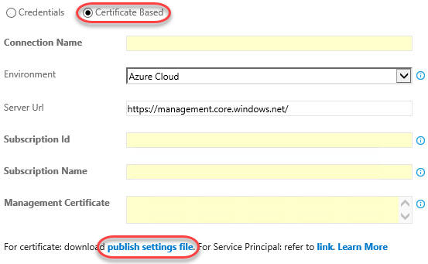

1. When prompted by the browser, select **Save As**, change the name to “creds.txt”, and save it to the desktop for easy access. Note that the browser may ask you to log in first.
2. Open “creds.txt” using notepad. It’s XML, but you’ll be able to parse out what you need by hand.
3. Locate the three key fields needed to configure the Azure connection. Note that if you have multiple Azure subscriptions, you’ll need to make sure you’re working with the one used to create the SQL server and web site earlier.

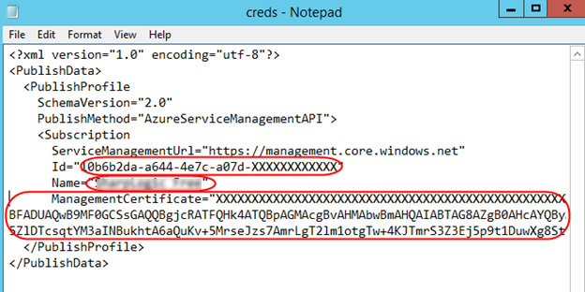

1. Set the **Connection** name to “Fabrikam Azure” and configure the remaining details using the data from creds.txt. Note that **Management Certificate** is all on the same line, despite the appearance with word wrapping. Click **Verify connection** to confirm and **OK** to continue.

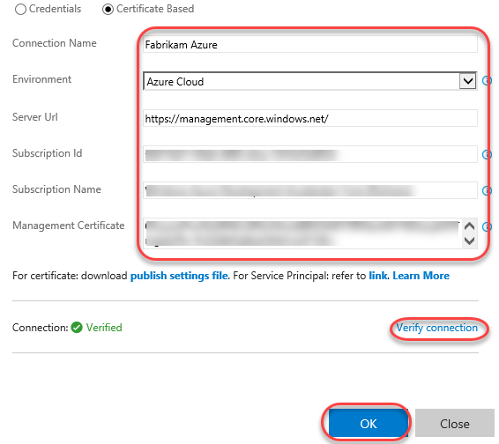

1. After the connection has been created, you can close this tab.
2. Return to the releases tab. Click the **Refresh** button next to the **Manage** link. This will enable you to select the **Azure Subscription** connection you just created. Type in the **Web App Name** of the Azure web site created earlier and select the **Web App Location** used during creation.

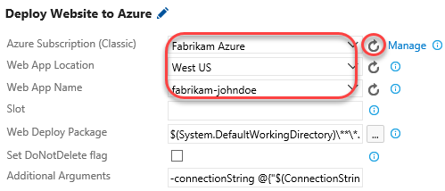

1. Set the **Web Deploy Package** to the path below. Note that you could also specify additional arguments, such as a connection string, as part of this workflow if required.

$(System.DefaultWorkingDirectory)/Fabrikam Development CI/drop/_PublishedWebsites/FabrikamFiber.Web_Package/FabrikamFiber.Web.zip

1. Save the release.

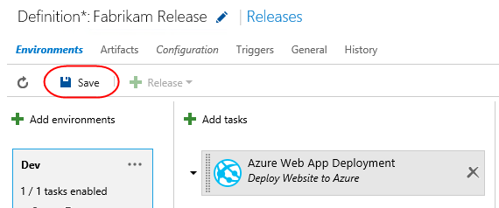

## Task 4: Checking in a change to kick off the release workflow

1. Return to the code browser tab and locate the path below.

$/FabrikamFiber/Dev/FabrikamFiber.CallCenter/FabrikamFiber.Web/Global.asax.cs

1. Click the **Edit** button and comment out the **Database.SetInitializer** call in **Application_Start**. This won’t work properly in Azure, so it needs to be commented out. It doesn’t matter since the DB was already set up manually.
2. Save the file to check it in.

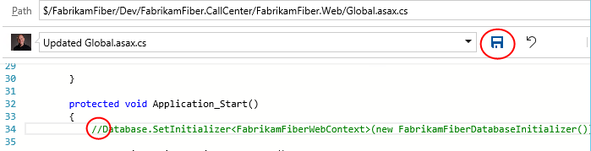

1. Return to the releases tab in the browser. If the new release process doesn’t show up within a minute, refresh the window or use the refresh button. Approve the first two requests to begin the Azure deployment. You’ll know the bits have been deployed to production when you’re asked for the post-release signoff.

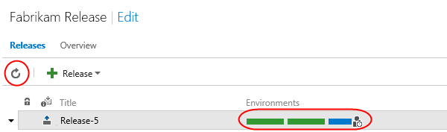

1. Open a browser tab to the Azure site to confirm the deployment worked as expected. For example, if you named your site fabrikam-johndoe, then the URL would be <http://fabrikam-johndoe.azurewebsites.net>.

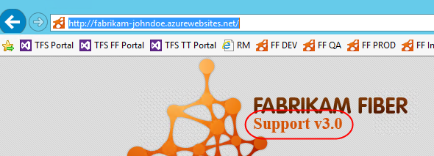

1. Return to the releases tab and approve the release by clicking the icon, optionally entering a message, and clicking **Approve.**

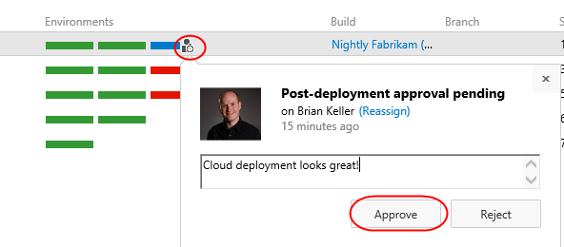

1. Now everyone can easily see that the most recent release made it all the way through the release pipeline and is live in the cloud.



## Task 5: Deploying to Azure from Visual Studio

1. While all of the automation available in **Team Foundation Server** provides a great “continuous integration, continuous deployment” (CICD) experience, sometimes you may still want to manually deploy a build directly from Visual Studio. And thanks to tight integration between Visual Studio and Azure, it’s really easy to do.
2. Open a new instance of **Visual Studio** from the taskbar.
3. Open **FabrikamFiber.CallCenter.sln** from the **Start Page**.

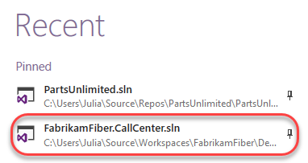

1. We’ll continue using the support version number as our change example. In **Solution Explorer**, double-click **FabrikamFiber.Web\Views\Shared\_Layout.cshtml** to open it.

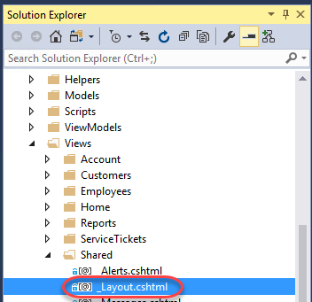

1. Locate the **<h2>** tag with the support version and increment it to **v5.0**.

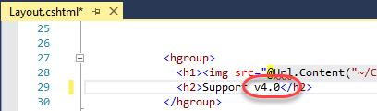

1. In **Solution Explorer**, right-click the **FabrikamFiber.Web** project and select **Publish**.

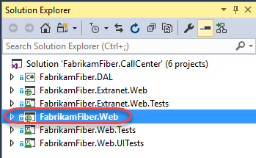

1. Since this is the first time this project is being published to Azure, we will need to set up a publish profile. Select the **Profile** tab and click **Microsoft Azure App Service**.

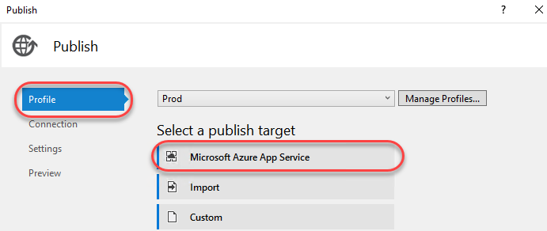

1. Since there is not yet an account associated with this instance of **Visual Studio**, click **Add an account** from the dropdown.

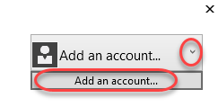

1. Sign in using the Microsoft account your Azure subscription is associated with.
2. Select the **App Service** created earlier and click **OK**.

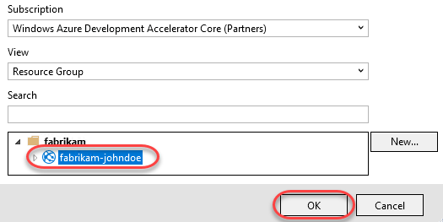

1. The **Connection** tab is automatically populated with the deployment information required to push the project out to the right Azure App Service. There’s nothing to tweak here, so click **Next**.

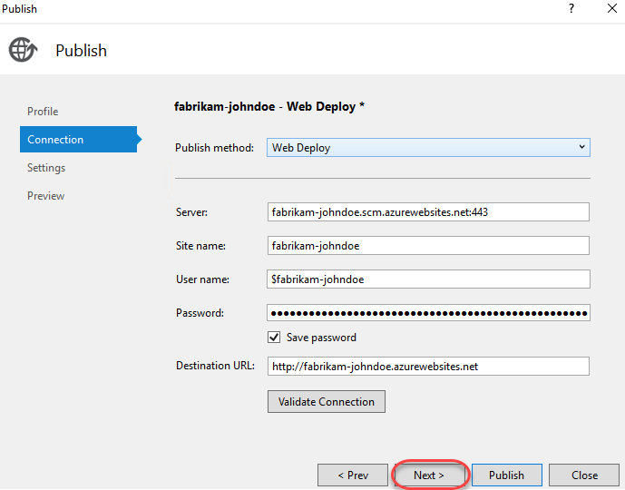

1. The **Settings** tab enables you to specify the build configuration you want to deploy, as well as file publication options and settings for databases detected from **Web.config**. We already configured the connection string earlier, so click **Next** to continue.

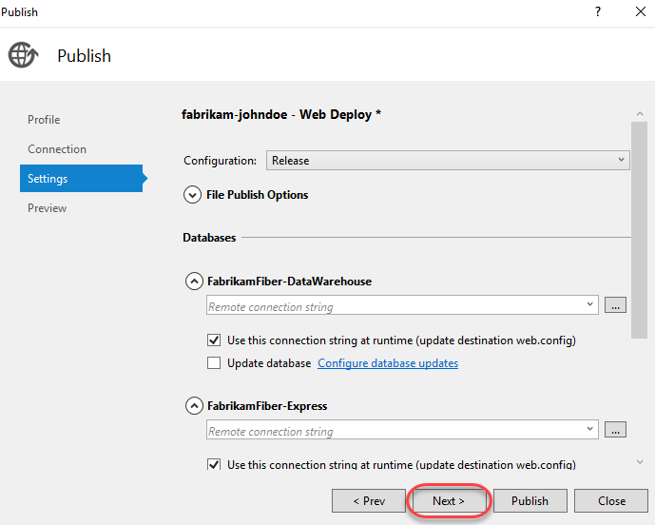

1. The **Preview** tab enables you to see exactly what will get pushed up to the service. Click **Start Preview** to see which files have changed.

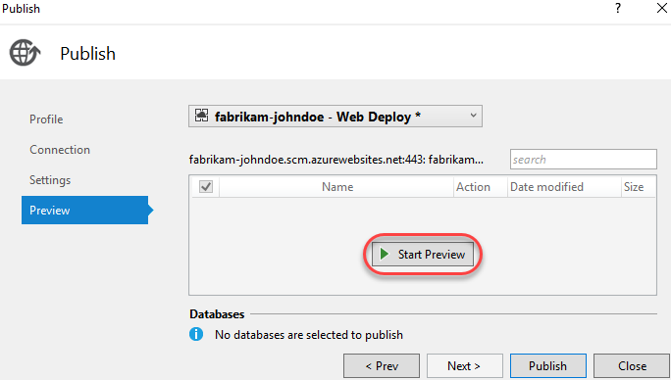

1. There should only one file: **_Layout.cshtml**. Click **Publish**.

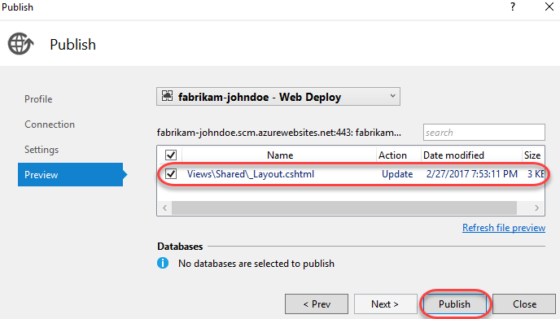

1. You can review the publish progress in the **Web Publish Activity** pane at the bottom if **Visual Studio**. It should complete quickly since the one file being pushed is small.

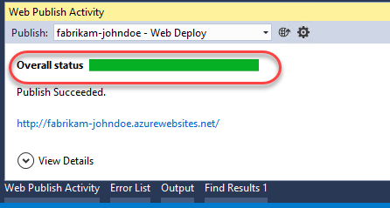

1. Upon completion, the integrated browser will open to the public URL. Note the new version number, which confirms the deployment was successful.

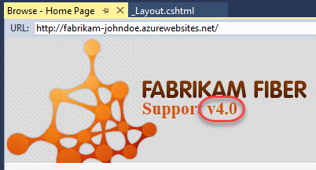

## Task 6: Working with deployment slots

1. Azure App Services offer **deployment slots**, which are parallel targets for application deployment. The most common scenario for using a deployment slot is to have a staging environment for your application to run against productions services, but without replacing the current production application. If the staging deployment passes review, it can immediately be “swapped” in as the production slot with the click of a button. As an additional benefit, the swap can be quickly reversed in the event an issue is uncovered with the new build.
2. Return to the browser window open to the Azure portal.
3. Select the **Resource groups** tab from the left menu. Locate and click the **fabrikam** group created earlier.



1. Click the **App Service**.

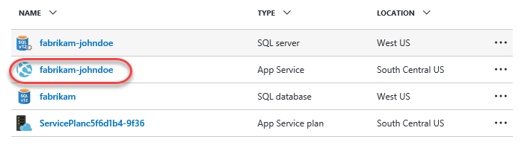

1. Select the **Deployment slots** tab and click **Add Slot**. Note that the **production** slot is considered a “default” slot and is not shown as a separate slot in the user experience.

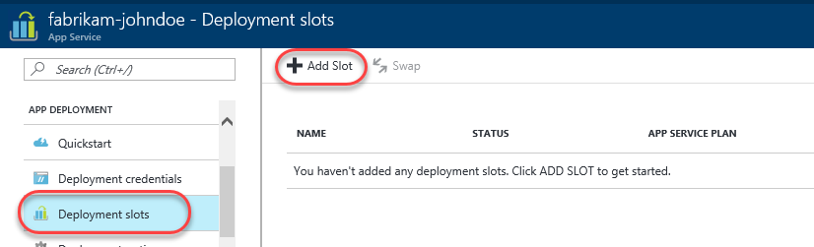

1. Enter a **Name** of **“staging”** and select the **Configuration Source** that matched your existing deployment (there should be only one). Click **OK** to create the slot.

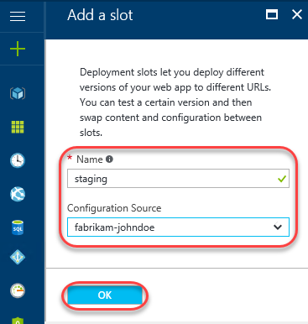

1. Return to **_Layout.cshtml** in **Visual Studio**. Update the version text to **“5.0”**.

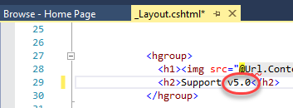

1. In **Solution Explorer**, right-click the **FabrikamFiber.Web** project and select **Publish**.



1. The new slot is treated as a unique deployment target, so we’ll need to set up a profile for it. However, your Microsoft and Azure accounts are already configured, so the experience will be even smoother. Select the **Profile** tab and click **Microsoft Azure App Service**.

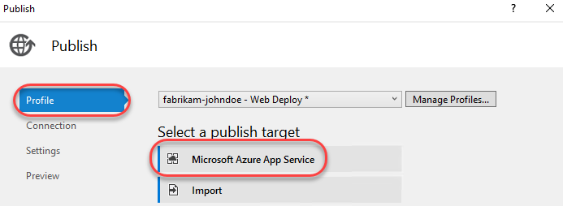

1. Drill down to select the **staging** deployment slot and click **OK**.

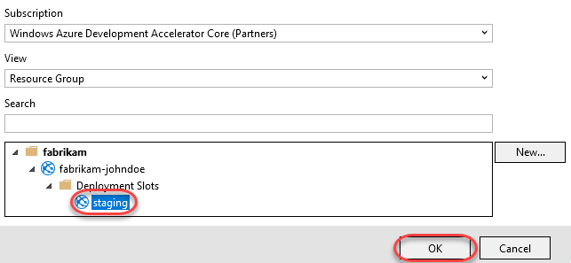

1. On the **Connection** tab you’ll notice that the settings are very similar to the **production** slot, except that the text **“staging”** is inserted within various strings. The key place of interest is that each URL differs from the production slot by having **“-staging”** inserted at the end of the lowest subdomain. For example, if your subdomain started with **“fabrikam-johndoe”**, then a slot named **“staging”** would have the URL **“fabrikam-johndoe-staging”**. Click **Publish** to deploy.

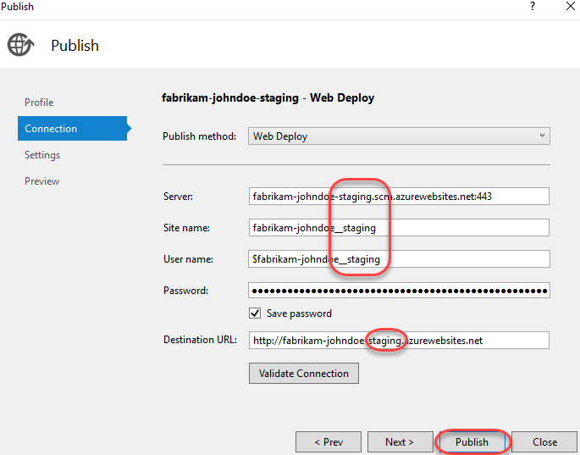

1. Once the deployment finishes you’ll see the built-in browser navigate to the staging slot, which can be verified via the support version number.

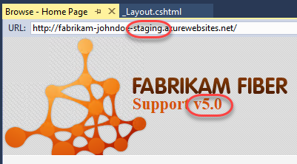

1. However, if you take the **“-staging”** out of the URL and press **Enter**, you’ll see that the production site is still on v4.0, as expected.

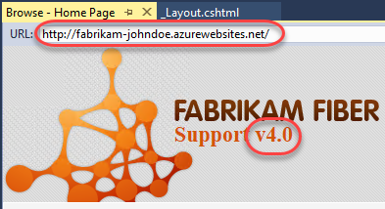

1. Expand the **Server Explorer** from the left side of Visual Studio.

C:\Users\Ed\AppData\Local\Temp\SNAGHTML3f3c5532.PNG

1. Drill down into the **Azure** node to review all of the assets accessible from within the IDE. Note the **production** slot is at the default level while the **staging** slot is one level deeper under **Slots**. You can do a lot from this pane, including opening file for editing (and saving back to Azure), reviewing logs, managing **WebJobs**, and more.

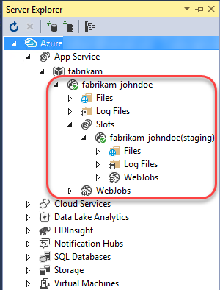

1. Return to the browser window open to the **Azure portal**. Click **Swap** in the slots blade.

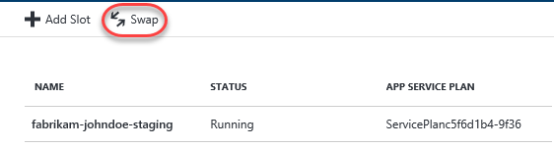

1. The default options here are exactly what we want: to swap the production and staging slots. Click **OK**. Note that if your apps rely on **slot-level configuration settings** (such as connection strings or app settings marked “slot”), then the worker processes will be restarted. If you’re working under those circumstances and would like to warm up the app before the swap completes, you can select the **Swap with preview** swap type.

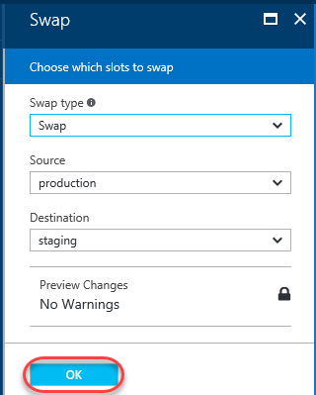

1. Return to **Visual Studio** and refresh the built-in browser by right-clicking with the document and selecting **Refresh**. Note that you can’t **F5** since that would build and run the solution.

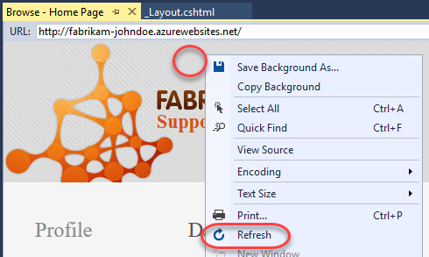

1. The **production** site should now show the **v5.0** as expected.

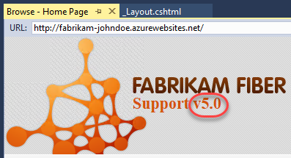

1. You can also confirm that the **staging** slot is now hosting the former production build of **v4.0**. In the event something bad happened with the v5.0 build, you could simply run the swap again and this running build would be back in production.

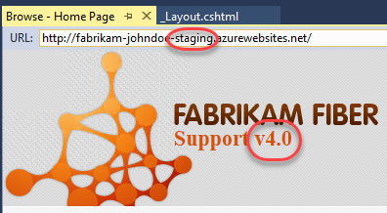

1. It’s important to note that while we deployed to the staging slot using Visual Studio, you could have just as easily set up CICD in TFS to deploy to the staging slot as well. There are even tasks to automate the swapping of slots, so you could set up everything you need in the release definition.